Information on BASIC – Brain and Spinal Injury Centre

## Description

“BASIC exists to serve people recovering from acquired brain injury and spinal injury and their families. The charity specialises in centre-based services for people who have undergone treatment for a traumatic head injury, brain haemorrhage, brain tumour, stroke or similar conditions. Our services also help people manage long-term neurological conditions.”

“We have a proven track record of working with partners on multiple rehabilitation projects, from delivering workshops on the CAREN and joint research projects with universities to working with case managers offering rehabilitation programmes to their clients.”

## Funding

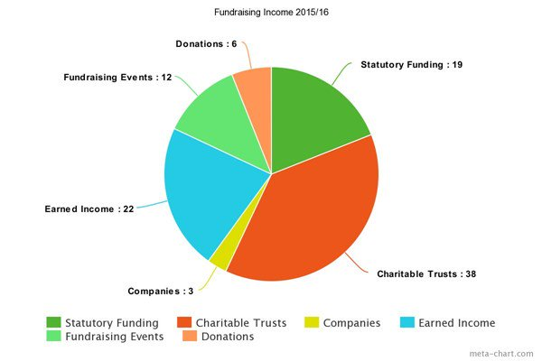Some of their funding comes from “Earned Income” which, along with mentions of costs elsewhere, leads me to believe the clients have to pay some amount (I have not seen a mention of the NHS), although they do state “Here at BASIC, we believe that everyone should access to high-quality rehabilitation services after suffering from brain and spinal injury. We offer a range of services that are suitable for severe injuries to minor injuries. We offer everyone the opportunity to access our services, all you have to do is fill in one of our self-referral forms and let us help you.”

And the use of funds:

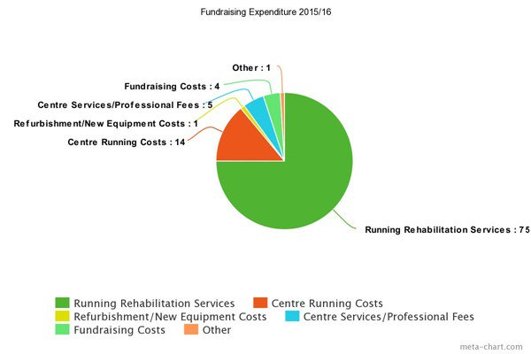

list of funders: <https://www.basiccharity.org.uk/Blogs/our-funders>

## Virtual Reality Therapy

Our main interest is their use of Virtual Reality and a couple of robotic systems to rehabilitate patients: <https://www.basiccharity.org.uk/virtual-rehabilitation>

The virtual environments are “motivating, engaging, and fun for the patient”.

Looks like quite expensive equipment

Equipment is held in house and patients perform the exercises with a therapist’s guidance.

No assisted motion mentioned on the virtual reality therapy page

Looks to be primarily lower body and balance focussed rehabilitation

## Physically Assisted Therapy

In addition to virtual reality therapy, they also provide physical support facilities

<https://www.basiccharity.org.uk/physical-support>

this includes:

* a specially designed assisted exercise suite
* YouGrabber which uses virtual reality games that focus on finger, hand, and arm coordination
* Berkel Bike which uses a cycle trainer connected to a PC, giving the patient access to a variety of virtual reality and training software packages

YouGrabber looks like the main thing that we would be interested in discussing.

## General Contact Info

“To find out more about the YouGrabber email bodybasic@basiccharity.org.uk or call 0161 707 6441”

It’s the same email and phone number for the other physical support services.

Their information on strokes, and life after a stroke: <https://www.basiccharity.org.uk/stroke>

“Contact Us

You can contact us online, call us or write to us.

Call us: 0161 707 6441

By Email:

Fundraising, Events and Volunteering: tom@basiccharity.org.uk

Virtual Reality Rehabilitation Services: enquiries@basiccharity.org.uk

General Rehabilitation Services: enquiries@basiccharity.org.uk

Other: enquiries@basiccharity.org.uk

Write to us: Brain and Spinal Injury Centre, 554 Eccles New Road, Salford, M5 5AP

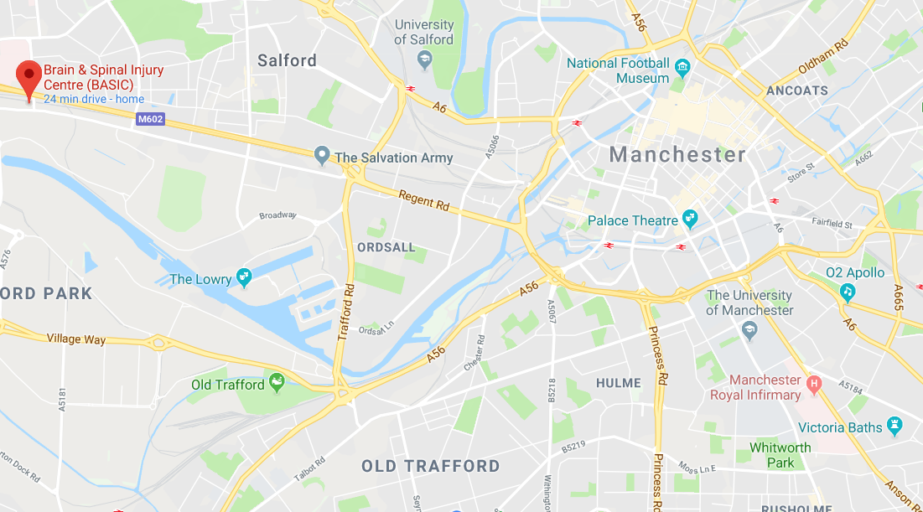

It’s a 25 minute drive and if I can’t get a lift I can probably find public transport. If I go home for the weekend I could check it out on the Monday, then return to Leeds either later that day or on the Tuesday.

## Staff

Staff list (9 members of staff):

<https://www.basiccharity.org.uk/Pages/FAQs/Category/staff>

They also seem to use volunteers.

Staff of most interest to us:

Wendy Edge – CEO

[wendy@basiccharity.org.uk](mailto:wendy@basiccharity.org.uk)

<https://www.linkedin.com/in/wendy-edge-1019a51a/>

Only other contact information given in the LinkedIn profile is her Twitter account

Sylvia Moss – Neuro-Physiotherapist, BodyBASIC and AIR Manager

[bodybasic@basiccharity.org.uk](mailto:bodybasic@basiccharity.org.uk)

<https://www.linkedin.com/in/sylvia-moss-nee-marginson-580b0b65/>

Sylvia appears to be our best bet as she is “actively involved in research with collaborative studies at the universities for the virtual reality equipment at BASIC”

Other staff involved with BodyBASIC (which is the area that YouGrabber is under) seem to be assistants.

Her contact email is listed as the same as the general one for getting in contact regarding BodyBasic.

She is currently working with "MMU and STrathclyde and Salford university”

She spent 26 years working as a neurothisitherapist in stroke services.

The only contact information available publicly on LinkedIn is her LinkedIn profile.

## Other Notes

I like their website

There are certifications for Computer Assisted Rehabilitation Environment training and Computer Assisted Rehabilitation Environment advanced operation and programming training